Topic review — Topic 3: Composite functions, transformations and inverses

Short answer
- Consider the equations , and , .
a Prove that is defined.
b Find the rule for and state the domain and range.
c Prove that is not defined.
d Restrict the domain of to obtain a function such that exists.

e Find and state the domain.
- A function has the rule , .

c Sketch the graph of , . State the domain and range, and give the equations of any asymptotes.
d Find the rule for the inverse, and state its domain and range.
e Specify whether the inverse is a function or a relation. Give reasons for your answer.
f Sketch the graph of the inverse on the same set of axes as the original function. Include the points of intersection on your graph
- Indicate whether each of the following functions has an inverse function. In each case, give a reason for your decision. If the inverse is a function, write the rule for the inverse function in function notation.
a ,
b ,
c ,
d ,
e ,

6a Consider the functional equation defined by . Which of the
following functions satisfies this equation?
i
ii
iii
b Consider the functional equation defined by .
i Show that the function obeys this rule.
ii Show that the function obeys this rule.
c For , show that can be written in the form and find the value of .

Multiple choice
- If and , then is equal to:

A

B

C

D

E
- For the functions below, which of the following compositions is not defined?
A
B
C
D
E
- If , then would exist if:

A ,

B ,

C ,

D ,

E ,
- If , which of the following functional equations is true?

A

B

C

D

E

- The graph of the function is transformed so that its new rule is . The transformations that have been applied to are:

A dilation by a factor of parallel to the -axis, dilation by a factor of 2 parallel to the -axis, a translation of 1 unit in the negative -direction and a translation of 4 units up

B dilation by a factor of parallel to the -axis, dilation by a factor of 2 parallel to the -axis, a translation of 1 unit in the positive -direction and a translation of 4 units up

C dilation by a factor of parallel to the -axis, dilation by a factor of parallel to the -axis, a translation of 1 unit in the negative -direction and a translation of 4 units up

D dilation by a factor of parallel to the -axis, dilation by a factor of parallel to the -axis, a translation of 1 unit in the positive -direction and a translation of 4 units up

E dilation by a factor of 2 parallel to the -axis, dilation by a factor of parallel to the -axis, a translation of 1 unit in the negative -direction and a translation of 4 units up
- The following matrix equation is applied to .

This causes to be:
A reflected in the -axis and dilated by a factor of 2 from the -axis
B reflected in the -axis and dilated by a factor of 2 from the -axis
C reflected in the -axis and dilated by a factor of 2 from the -axis
D reflected in the -axis and dilated by a factor of from the -axis
E reflected in both axes and dilated by a factor of 2 from the -axis
- The rule for the inverse of the graph shown would be:

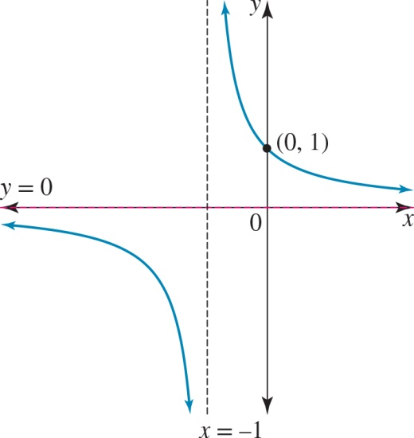

A
B
C
D
E
- For the function to have an inverse, its maximal domain:
A must be restricted to
B must be restricted to
C must be restricted to
D is
E must be restricted to
- The inverse of the function defined by , would be:
A ,
B ,
C ,
D ,
E ,

Extended response
- Consider the function defined by .
a Sketch this graph, giving the domain and range of the function.
b Find the rule for the inverse.
c Sketch this inverse on the same set of axes that you used for .
d Restrict the domain of to the form of so that the inverse is also a function.
e State the rules for the restricted and using function notation.
f Sketch the graphs of and on one set of axes.
g Show that .
- Consider the function defined by the rule , where is the maximal domain for .
a Find .
b Describe the transformations that would have been applied to in order to achieve .
c Write a matrix equation that defines these transformations and solve the matrix equation to confirm this is correct.
d Define the rule for the inverse function and give its domain and range.
e Sketch the graphs of and on the same set of axes.
- a If , and , , where is a positive constant, find the value(s) of such that both and are defined.
b The transformation is defined by , where , , and are non-zero real numbers. If the image of the curve is , find the values of , , and .
- a If , show that it obeys the functional equation defined by .
b If , show that it obeys the functional equation defined by .

Topic review — answers

Short answer

1 a For to exist, the range of the inner function, , must be a subset of or equal to
the domain of the outer function, .

Therefore, is defined.

b

Domain = , range =

c For to exist the range of the inner function, must be a subset of or equal to
the domain of the outer function, .

Therefore, is not defined.

d ,

e

Domain =

2

c ; domain = and range =
Asymptotes: and
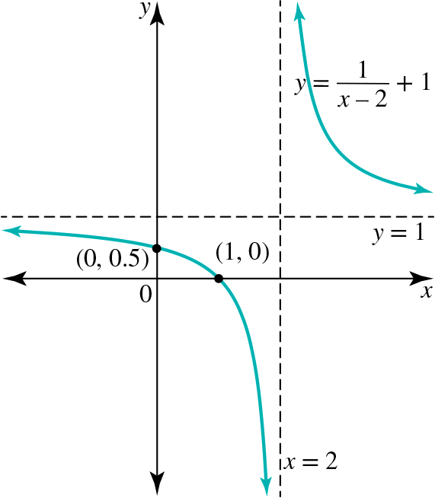

d , domain = and range =

e The inverse is a one-to-one function.

f

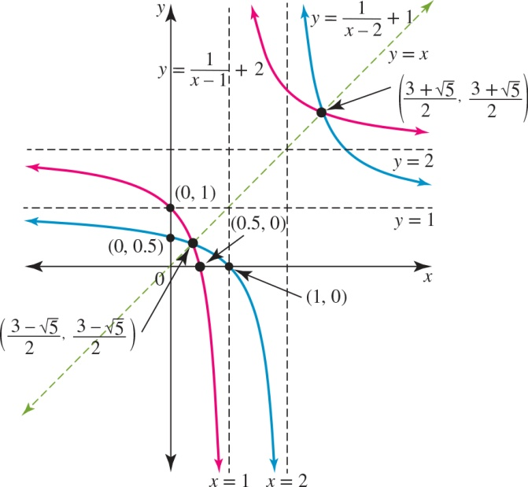

3 a One-to-one inverse function: ,

b Not a function, as it is a one-to-many mapping.

c Not a function, as it is a one-to-many mapping.

d Not a function, as it is a one-to-many mapping.

e One-to-one inverse function: ,

6 a i No ii Yes

iii Yes

b i
Because is positive in the 2nd quadrant,
.
Therefore,

ii
Because is negative in the 2nd quadrant,
.
Therefore,

c

Multiple choice

1 A 2 D 3 A 4 C

6 D 7 B 8 C 9 B 10 D

Extended response
1 a, c The domain of is and the range of is .
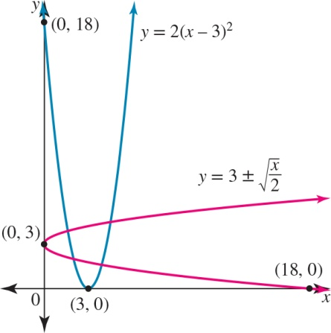
b ; domain = and range =
d The domain should be .
e ,
,
f
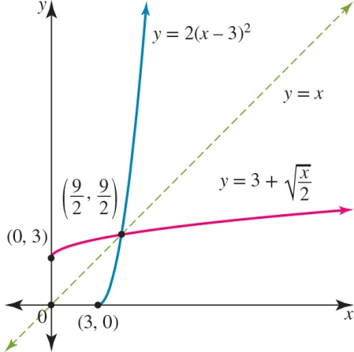
g
2 a
b One possible answer is:
Dilated by a factor of parallel to the -axis or from the -axis, translated 2 units to the right or in the positive -direction and translated 1 unit down or in the negative -direction
c
d with range =
e
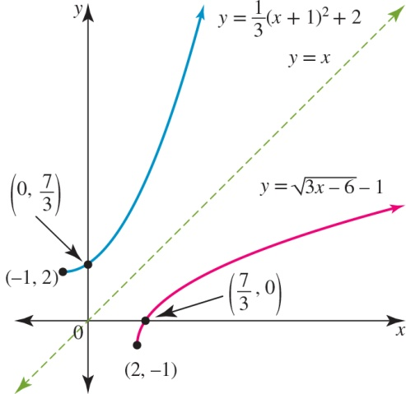
3 a
b , , and
4 a
:
b
:

